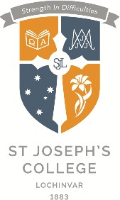
trousers.

College Uniform Overview
The uniform shop is located on our College site and is run by an independent company called Alinta, a company specialising in school uniforms.

Note re boys shirt and girls blouse. These may be worn untucked as they have been tailored for this, however, senior boys must tuck the shirt in when wearing a tie and long

School uniforms demonstrate belonging to a community. It is important that the uniform is worn correctly. Many aspects of uniform meet WHS requirements. All items other than shoes are available from the campus uniform shop.

The correct uniform must be worn at all times i.e. not added to or include bits and pieces of the different uniforms. If the sports uniform is required to be worn then it should be full sports uniform. If full sports uniform cannot be worn, full school uniform must be worn. Students must not substitute sports uniform for formal school uniform by choice. If part of the school uniform is not able to be worn, a parental note if required.

If in doubt with any of these requirements, please check with the school.

Junior Girls (Year 7-10) Senior Girls (Year 11-12)

Uniform Specifications
- Black polishable lace up leather shoes
- White Alinta socks with blue stripe
- Blue pin stripped skirt or blue pin stripped tailored shorts
- Chambray shirt (darker fabric)
- “Sax” coloured Jumper (Compulsory)
- Navy soft shell jacket (additional / optional extra layer of warmth)
- Bucket hat
- Optional navy stocking in winter
- College scarf
- Optional navy pants
Students wear the Jumper as the first layer of warmth, the soft shell jacket is the additional
/ optional extra layer of warmth.
Uniform Specifications
- Black polishable lace up leather shoes
- White Alinta socks with blue stripe
- Blue pin stripped skirt or blue pin stripped tailored shorts
- Chambray shirt (lighter fabric)
- “Sax” coloured Jumper
- Navy blazer (Compulsory Terms 2-3)
- Bucket hat
- Navy stockings (Compulsory Term 2-3)
- College scarf
- College tie
- Optional navy pants
Students wear the blazer as the first layer of warmth in Term 2-3 (Compulsory)
Jumper is optional.

Junior Boys (Year 7-10) Senior Boys (Year 11-12)
Uniform Specifications
- Black polishable lace up leather shoes
- Grey Alinta socks with blue stripe
- Charcoal grey shorts – (Optional long pants in Term 2-3)
- Chambray shirt (darker fabric)
- “Sax” coloured Jumper
- Navy soft shell jacket (additional / optional extra layer of warmth)
- Bucket hat
- College scarf
Students wear the jumper as the first layer of warmth, the soft shell jacket is the additional / optional extra layer of warmth.
Uniform Specifications
- Black polishable lace up leather shoes
- Grey Alinta socks with blue stripe
- Charcoal grey shorts – (Compulsory long pants in Term 2-3)
- Chambray shirt (lighter fabric)
- “Sax” coloured Jumper
- College tie
- Navy blazer (Compulsory Term 2-3)
- Bucket hat
- College scarf
Students wear the blazer as the first layer of warmth in Term 2-3 (Compulsory)
Jumper is optional.
If boys are wearing a blazer, long pants are compulsory.

Sports Uniform Year 7-12
Sports Uniform (7-12)
PLEASE NOTE:
Uniform Specifications
- Sports shoes
- White Alinta socks with blue stripe for females,
- Grey Alinta socks with blue stripe for males
- Grey shorts – (male and female cut)
- Optional grey tracksuit pants for Term 2-3
- Navy polo shirt
- Rugby jersey
- Soft shell jacket (optional / additional extra layer of warmth)
- Bucket hat
Students have the options of wearing either the sax formal jumper or rugby jersey. Senior students (Year 11-12), must get changed at school for practical lessons.
Junior students (Year 7-10), may wear their PE uniform to and from school on practical days only.

Special Notes
- students are only allowed to wear one small stud or sleeper in each ear. They must be confined to the earlobes. Wearing them in any other part of the body is not acceptable.
- one plain silver or gold bracelet or bangle is allowed to be worn
- one plain silver or gold necklace holding a religious cross or medal may be worn (this must be tucked into shirt or blouse)
- one plain ring may be worn
- hair is to be of one natural colour. hair accessories, of school colour, should be kept to a minimum; navy or black in colour.
- In cases where hair is long, students shall tie their hair back to ensure that it is away from their face; seniors are permitted to have their hair out except in practical lessons
- haircuts need to be neat and reflect our expectations and values – undercuts, wedging, mullets, Mohawk, rattails etc are not acceptable.. Students whose haircuts are deemed unacceptable will be asked to comply with school policy
- boys are to be clean shaven.
- makeup including mascara, eyeliner, lipstick and blush is not allowed. Tinted moisturizer / sunscreen only may be worn at school; nail polish to be clear or neutral
- False nails are not permitted – this is a WH&S issue
- False eyelashes are not permitted
- Students who have tattoos are to have them covered at all times

Out of Uniform Days: Student Dress Code

To comply with insurance and safety regulations, and a sense of modesty, the following guidelines have been established for out of uniform days.

- Closed footwear required for safety reasons (leather for workshop, kitchen, laboratory).
- No offensive language / slogans, drug related images on clothing.
- No exposed midriffs
- Normal rules apply for jewellery
- No make-up
- Hair should be tied back as normal
- No short shorts
- No singlet shirts

School Shoes
Black hard leather polishable lace-up shoes
CORRECT √ | INCORRECT x
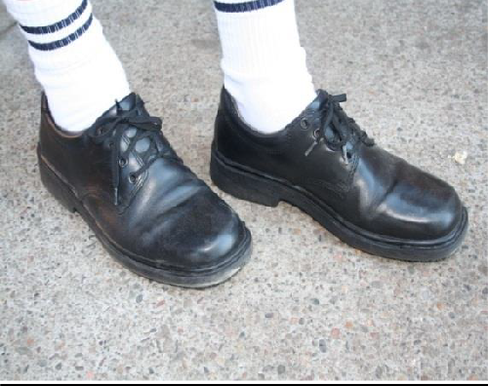 | 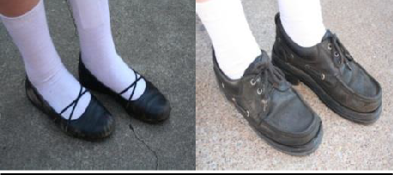  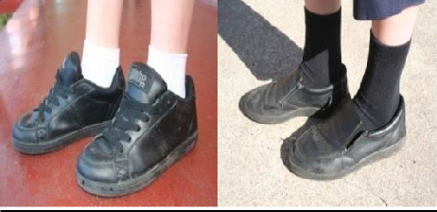  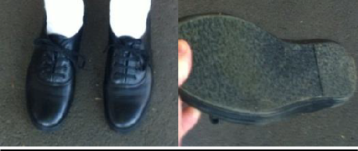

Sport Shoes  Sport shoes must be supportive sports joggers and have laces  CORRECT √  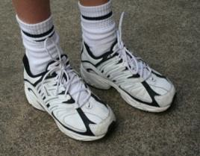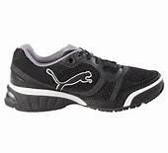  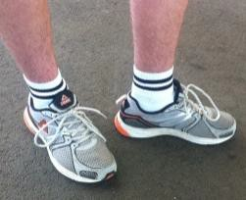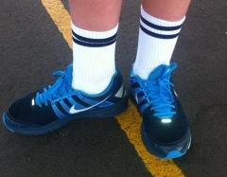  Laces done up, not tucked in  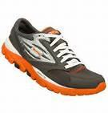  Solid, supportive heel counter  Clearly defined, supportive arch and heel. | INCORRECT x  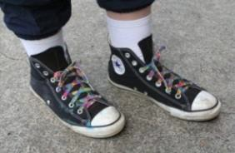  No boots/high tops  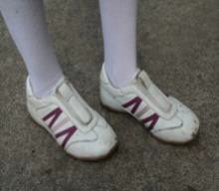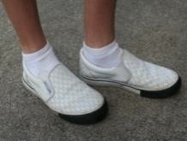  No slip on shoes  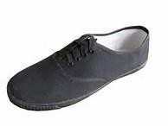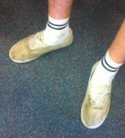  No canvas shoes  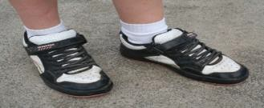  No velcro or straps
